Stronger Communities Programme
Community Anchor Organisations Grants
Application Form CAO-04

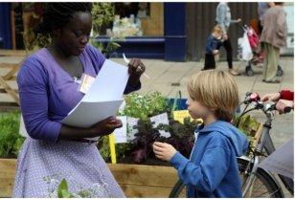
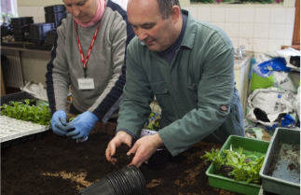
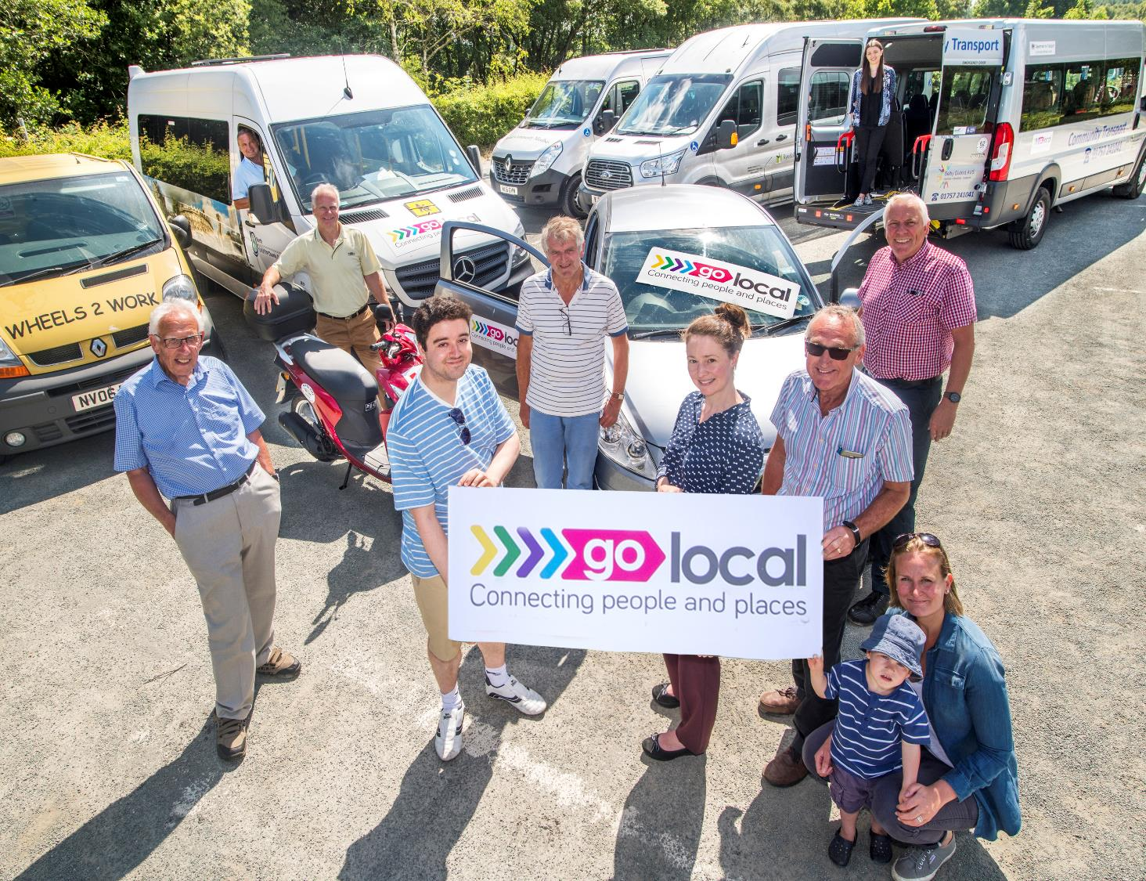
People|Places|Power
Building Stronger Communities in North Yorkshire
How to apply

This form should be completed for all applications for Place Based Community Anchor Organisation Grants.

Applications should be submitted by 12 noon on 16th January 2026. Please return an electronic copy of your completed application form and any associated documentation or attachments by email to:

stronger.communities@northyorks.gov.uk

The application form must be returned as a word document.
Please do not convert it to a PDF.

Evaluation of Applications

Applicants will be notified regarding the outcome of their application by the end of February 2026.

Further information
If you would like further information about this opportunity or if you would like to discuss the submission of an application, please contact the Communities Locality Lead for Scarborough, Malton & Vale:

Karen Atkinson
Tel: 01609 534061
Email: karen.atkinson@northyorks.gov.uk

SECTION 1: TELL US ABOUT YOUR ORGANISATION

Q1 Name of your organisation: | Malton and Norton Area Partnership
Q2 Name of main contact: | Martin Brampton
Q3 Address of organisation or main contact: | 1 Newgate, Malton, YO17 7LF
Telephone: | 01653 524262
Email: | info@mnap.org.uk
Q4 What is the status of your organisation?
☒ Unincorporated community group
☐ Faith organisation
☐ A Registered Charity / CIO
(please state number)
☐ Other Not for Profit / Social Enterprise
(please state type e.g. CIC, Company Limited by Guarantee etc.)
☐ Other (please state)
Q5 How long has your organisation been established? |  |  | 23 years
Q6 For which place do you wish to be the Community Anchor Organisation? |  |  | Malton, Norton and adjoining Wards
Q7 Please tell us where your organisation is based and describe how you currently serve or have the potential to serve the area of Malton & Norton. What other places do you think your residents might visit to access services or build connections?
(Maximum 250 words)
The Malton & Norton Area Partnership (MNAP) was established in 2002 with the support of Yorkshire Forward, the former Regional Development Agency (RDA). Since then, MNAP has represented a wide cross section of our community and has achieved many notable successes which have improved facilities and services within our communities. It is a partnership with a formal constitution.

MNAP is a multi-sector organisation with members representing Malton and Norton Town Councils, North Yorkshire Council, cultural and voluntary organisations, local businesses and the main landowner (FWME). Recognising NYC’s ambitions for community organisations we continue to broaden our membership, and we have received positive feedback from a number of community organisations interested in becoming members.

Since its inception MNAP has been instrumental in helping to deliver a wide range of community projects including Malton/Norton Skate Park; Malton to Hovingham cycleway; the Renewal of the Lady Spring Wood Boardwalk. MNAP also played a significant role alongside Malton and Norton TC’s together with local community groups in the preparation of the Maton and Norton Neighbourhood Plan (adopted by NYC in 2024) as well as working with Yorkshire Water to address flooding and sewage emissions from the River Derwent.

MNAP is actively involved with the preparation of the Malton and Norton Investment Plan in conjunction with NYC and the Combined Authority and we are co-ordinating representations to the new North Yorkshire Local Plan.

MNAP also produces a quarterly community newsletter three times a year which is distributed to all households in Malton, Norton and beyond. (250 words)

Q8 Tell us about the Malton & Norton area.
What is great about it? Also, what challenges does it present for residents?
(Maximum 200 words)
The towns of Malton and Norton share a rich history stretching back over two thousand years.

The principal employment sectors are tourism and leisure; manufacturing and service industries; agriculture; and the racing industry. The vibrant town centres act as service centres for the surrounding rural hinterland and feature a high proportion of independent businesses.

Both towns have an active community infrastructure including 15 charities and health related groups, 7 from the arts/heritage sectors, 6 environmental groups and 5 education/ youth groups.

According to the latest indices of deprivation (2025) local residents are generally more deprived with lower income levels, older and suffer from ill health compared with other parts of North Yorkshire. People have poorer access to housing, and face challenging education and skill levels. There are relatively high levels of migrant populations and poor living conditions, with flooding, air pollution and sewage emissions posing particular challenges.

The emerging Investment Strategy for Malton and Norton identifies key challenges including vacant shops, poor connectivity between Malton and Norton and community fragmentation. It promotes better provision for young and disabled people and the need for improved greenspaces.

We will work with and mobilise the community groups to help address these challenges.
(199 words)

Q9 Which characteristics of a Community Anchor does your organisation demonstrate now? Please tell us about these in strength order with those characteristics you believe you show most strongly first using brief examples to explain your answer. It is important to be as accurate as you can in your self-assessment, remember the purpose of this investment is to support the development of Community Anchors so we don’t expect organisations to demonstrate all the characteristics or to be as strong in all areas.
See pages 5-9 of Invitation to Bid
(Maximum 800 words)
MNAP already demonstrates a number of the key characteristics for a Community Anchor, and we are already flexing our activities to ensure there is a close alignment of objectives. As an Anchor Organisation we would aim to strengthen our links with communities and business in the area so that we can help advocate and deliver “bottom up” initiatives in support of the more strategic actions and funding opportunities provided by NYC and the Mayoral Authority.

MNAP operates in an open and transparent way - meetings are generally open to the public, anyone can join our mailing list, minutes of meetings are published,

Our existing constitution states our core purpose is to:

- promote and support the development of facilities in Malton and Norton and its hinterland
- bring together representatives from local stakeholders, in order to seek community views and make recommendations, and act as a consultative body for the benefit of the wider community
- undertake such projects or initiatives that further the wellbeing of the entire community
- encourage the widest possible participation from representatives of the entire community

MNAP is a place-based organisation focussed on improving the quality of life and opportunities for those living and working on Malton, Norton and the surrounding parishes. It has, and is, making significant contributions to key policy documents which will impact our communities into the future, e.g. the North Yorkshire Council Local Plan and the Malton and Norton Investment Plan.

MNAP provides a voice for local people. Already, our membership is broadly based, including a North Yorkshire Councillor, members of Malton and Norton TC’s and representatives from resident, businesses and community sector and the major property owner (Fitzwilliam Malton Estate). We recognise the need to broaden our membership and have recently recruited the Local Lions and Rotary Clubs. As a Community Anchor we aim to further extend our membership to include a wider range of groups including representatives from the East European Communities, health organisations and young people’s groups to strengthen community resilience.

A collaborative approach, committed to working with other organisations in order to broker, facilitate, add value and deliver projects with partnership organisations is central to MNAPs approach. This is demonstrated by our leading role delivering projects with partners at Lady Spring Wood and the Norton Skate Park and our role co-ordinating representations to the North Yorkshire Local Plan. Lobbying, influencing and acting as a consultative body is a role that MNAP can develop representing the combined communities of Malton and Norton. Malton Town Council passed a resolution in support of MNAP application for anchor organisation.

Our members adopt a ‘can do mindset’. We want to be an instrument for change within the community and make things happen on the ground as evidenced by a number of the projects we have delivered and the wide ranging experience of our members. We want to expand our membership and attract those with skills and experience in social, economic and physical projects. In particular, we wish to help address the current fragmentation of voluntary action, and the thin spread of active volunteers. Bringing people together will strengthen their efforts and maximise their impact.

Over the course of its lifetime MNAP has primarily been concerned with project delivery rather than service delivery. We see a key part of our role communicating with local residents about events, successes and identifying new challenges we face in our area seeking to inform and encourage involvement and participation. The newsletters we have produced over 2025 are a good example of our approach.

MNAP is non-partisan and community led representing a cross section of local community interests. Our constitution states that MNAP is “To work for the benefit of the entire community within the mandate of its members, expressly as a non-political organisation”.

Since core funding was stopped many years ago, following the demise of RDA’s, MNAP has had to rely on project based funding which has acted as a constraint on its activities and impacted our financial resilience. A recent internal view concluded that moving forward this is not sustainable. Funding through the community anchor programme would enable us to be more active and more effective. Just one example might be that small community groups often have difficulty filling the role of treasurer. With administrative capability, we could offer a treasurer function at minimal cost, for example using a standard formula. We can also act as an interchange for local groups to seek and offer resources that could be shared. (744 words)

Q10 This funding is to build capacity and support the on-going development of Anchors. Tell us about any of the characteristics of a Community Anchor Organisation which you feel your organisation does not have or needs to develop more fully. What might help you to make progress in any areas you have identified?
(Maximum 500 words)
In early 2025 MNAP undertook a review of its operations against the backdrop of significant changes to local government structures following the formation of North Yorkshire Council (NYC) and setting up of the York and North Yorkshire the Mayor’s office and the York and North Yorkshire Combined Authority. It concluded that MNAP was well suited as a non-partisan delivery orientated groups representing a cross section of local community interests to the NYC ‘Local Community Partnerships’ model. The Mayor of York and North Yorkshire, who controls many devolved funding streams, also wants to deal with community partnerships.

In recent years MNAP has continued without any revenue support. Moving forward this is not considered to be sustainable.

We have already recognised the need to change and grow our organisation. We are in the process of seeking new members and sourcing admin support to help us with our activities and improve communication with the local community and between community groups.

Issues such as ill health, community cohesion, and environmental and social derivation are often tackled as ‘Silos,” but require a sustained multi/ agency cross organisation approach to their resolution. Also, over time, these issues will change and new concerns will emerge. MNAP aims to act as a forum for cross disciplinary action and is well placed to do so because of its current and expanding membership, together with the experience of those involved.

Skills and experience of current MNAP members is broadly based with volunteers bringing senior level experience in planning, regeneration, business and community work. We recognise the need to further bolster membership from the voluntary social and health sectors. For example, the capacity and access to health services has been highlighted as a major issue alongside age friendly and youth friendly support services. The ongoing performance and viability of both town centres is a recurring theme requiring attention. Employment opportunities and training/skills is an area where we see scope for MNAP to add value. Environmental challenges and opportunities around promoting bio-diversity and reducing pollution is another key issue.

Support from NYC as an Anchor Organisation would help MNAP attract new membership with a more diverse skill set, source an admin support officer and more organisational structure to help tackle this range of issues.
(370 words)

Q11a Tell us about your relationships with other local organisations in your area which address local needs. What evidence do you have that they will recognise you as well suited to the Community Anchor role?
(Maximum 250 words)
MNAPs membership includes nominated members of North Yorkshire, Malton and Norton Town Councils. Members regularly attend and are fully involved in MNAP meetings and initiatives. There is a close working relationship between these organisations and it is something we wish to foster into the future. Malton Town Council has endorsed MNAP’s bid to become a Community Anchor.

As a major landowner in Malton, the Fitzwilliam Estate also has a nominated member to the MNAP Executive and there is an opportunity to develop close partnership working to the benefit of the community and Estate through the development of “bottom up” regeneration initiatives. The Estate is also an active participant providing funding and facilitating projects and contributing to our newsletters. We are confident the Estate will recognise MNAP as a Community Anchor.

We also expect Local Lions and Rotary Clubs to become active members, Also in preparation of this application we have engaged with Kirkham Henry Village Trust, Camphill Village Trust, Next Steps and other groups. We have received positive feedback from a number of these organisations about a willingness to become involved which we expect will be taken forward if our bid for a community anchor is confirmed. (197 words)

Q11b Thinking about your answer to question 11a. It would help us if we could contact a couple of local organisations to have a short conversation with them about how they work with you. Please provide contact information for each organisation below including: name of the organisation, a contact name, phone number and email address.
Gail Cook  Clerk  Malton Town Council  clerk@malton-tc.gov.uk |  | Rebecca Wilkins  Fitzwilliams Malton Estate  rebecca.wilkin@maltonestate.co.uk
Q12 Please describe the services and activities that you are already delivering on a day-to-day basis.
(Maximum 500 words)
See page 10 of Invitation to Bid for the types of services and activities that an anchor may deliver
Building local partnerships is a key part of MNAP’s role and we see this increasing in importance if we are selected to be an Anchor Organisation. There are opportunities to develop networks across the business, social, voluntary and health sectors to exploit synergies and ensure a more joined up approach. MNAP has been working with Malton and Norton Town Councils on making representations to the North Yorkshire Local Plan. We worked in partnership with Norton Town Council on the skate board park and with Malton Town Council on the Lady Spring Wood project.

MNAP has been active helping to regenerate our communities. We have taken a lead from the action plan identified through the Neighbourhood Plan process which has been taken forward through actions plans prepared by both Malton and Norton Town Councils. MNAP is coordinating the monitoring of projects identified in these actions plans and is taking a lead role on certain projects, for example seeking to address the flooding and drainage issues which effect both Malton and Norton. (136 words)
SUPPORTING INFORMATION CHECKLIST
Please complete the checklist below and ensure that you have enclosed the relevant paperwork to support your application. Please note that this list is not exhaustive and you may be asked for additional supporting information which is not detailed below.

Supporting Information |  |  | Tick
Constitution / Memorandum and Articles of Association of Organisation (VCSE organisations) |  |  | ☒
A signed copy of latest audited accounts |  |  | ☒
Copy of Safeguarding Policy |  |  | ☐
Copy of Equalities and Diversity Policy |  |  | ☒
Please detail the insurance cover (i.e. public liability, employer liability, cyber insurance and / or buildings and contents) that your organisation has in place that is relevant to this application.
MNAP does not hold insurances as it has not taken primary responsibility for project delivery. We are open to considering this in the future dependent upon the activities we undertake.
Please confirm that the appropriate Disclosure and Barring Service (DBS) checks been carried out on those staff working with and / or supporting proposed beneficiaries.
Yes ☐ No ☐
Please confirm that your processes are GDPR compliant.
Yes ☒ No ☐
If there is a reason why you have been unable to supply any of the information outlined in Section 3, or if you believe we already have copies of this information please let us know in the box below.
MNAP does not have a safeguarding policy. We don't have any direct contact with young people and vulnerable adults but will keep this under review as our membership and activities may change over time.
Declaration:
I the undersigned confirm that I have the authority to submit this funding application on behalf of the organisation named in Q1
Signature of Applicant:
Date:
Data Protection:
All the information you enter on this form will be stored and held in accordance with relevant data protection legislation and used by North Yorkshire Council and its agents for the purpose of analysing, recording and publicising grants.
☒ | Please check the box to indicate you have read this statement and agree to your data being used for these purposes.
If you do not agree to this, please write stating this fact to the address below.
Stronger.communities@northyorks.gov.uk

