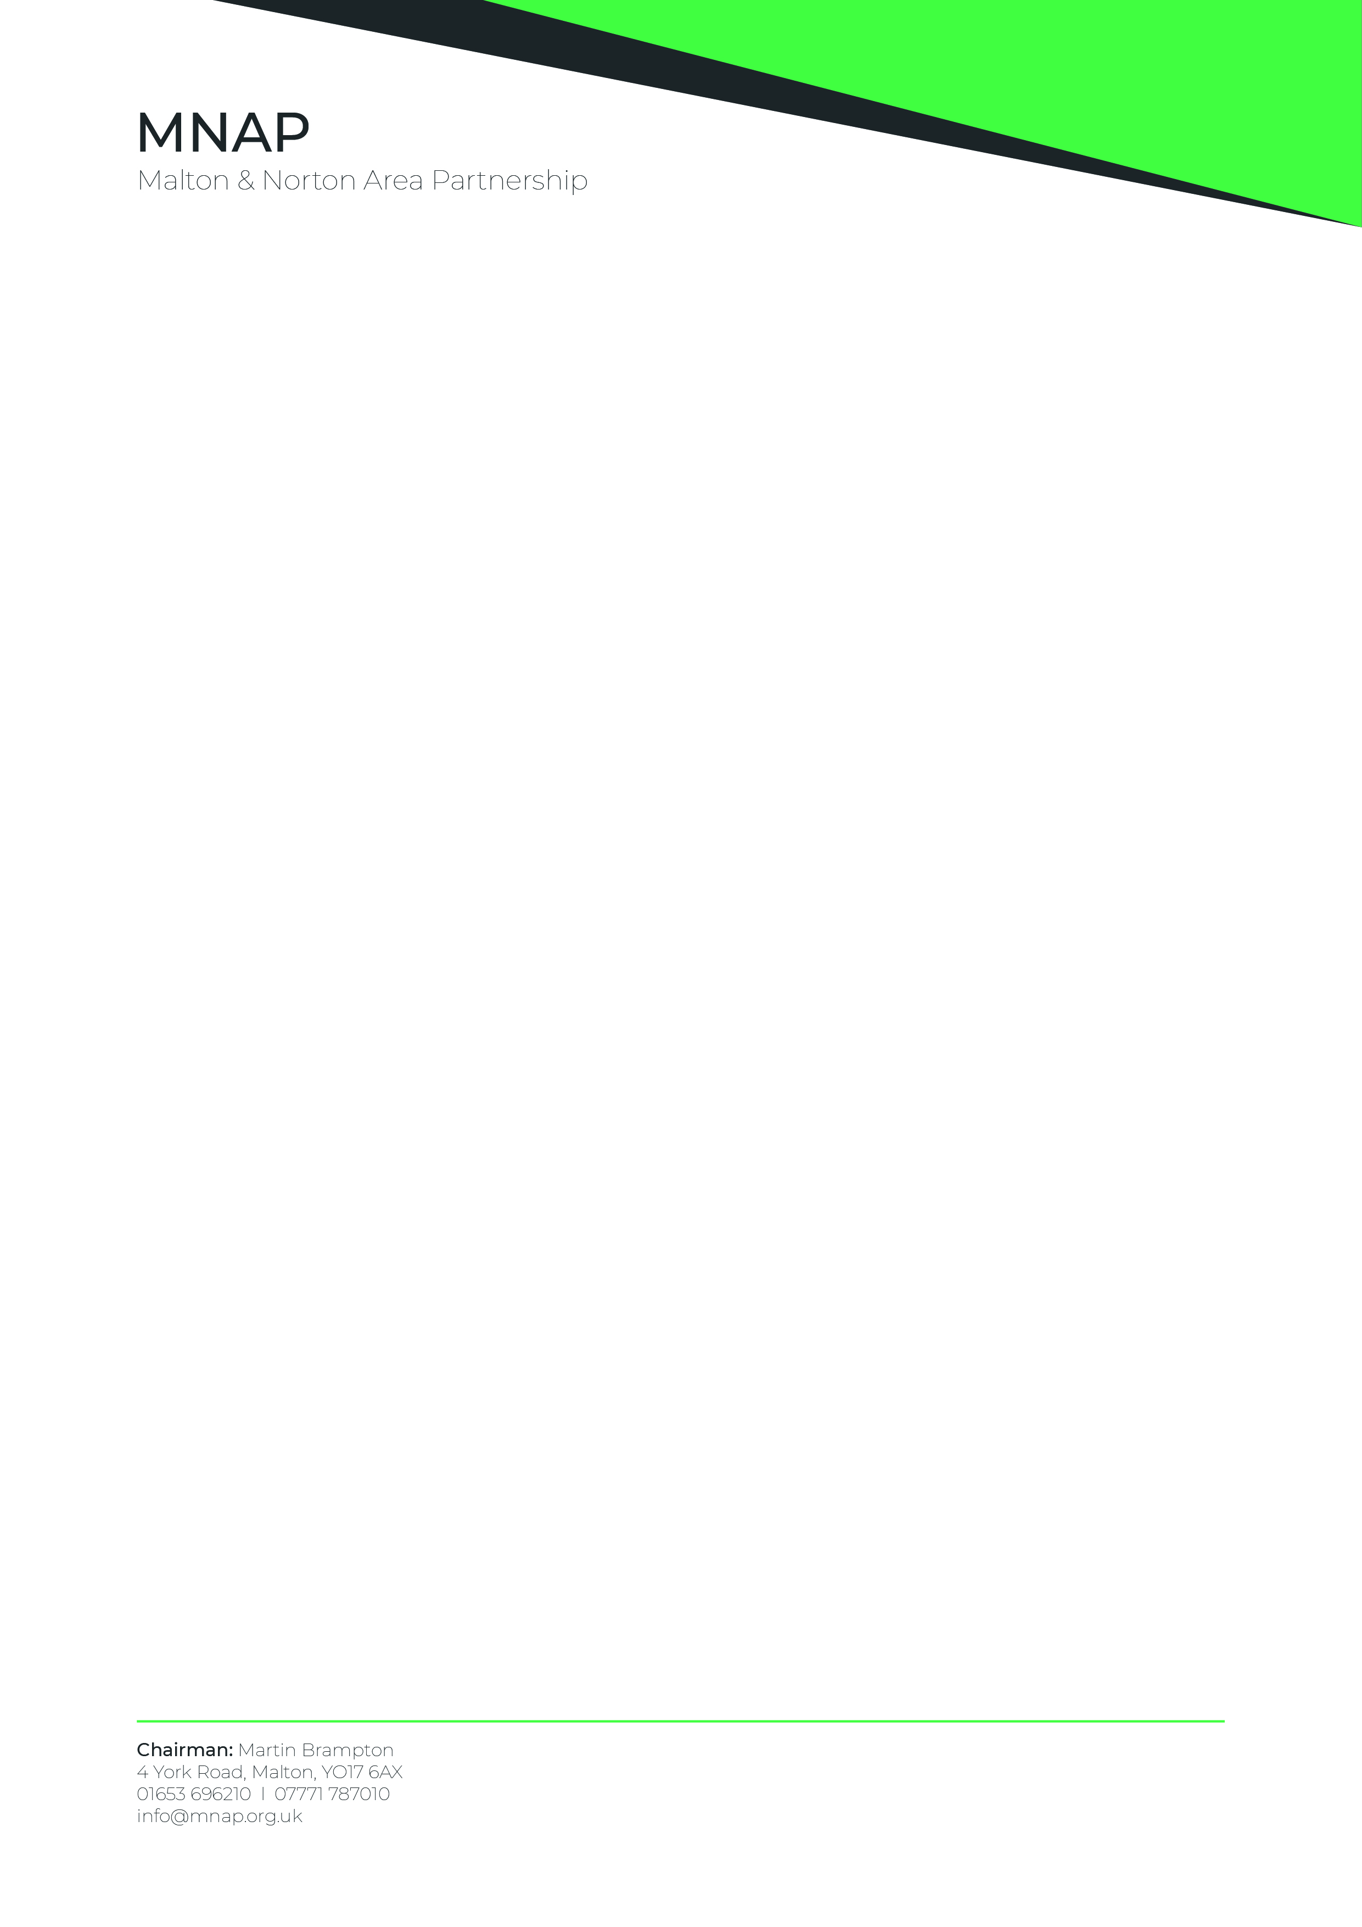
Planning Services (Ryedale Area)
North Yorkshire Council
Civic Centre
Stone Cross
Rotary Way
Northallerton
DL6 2UU 16th October 2025

Your Ref: ZE24/01683/MOUT
Land Off Rainbow Lane Malton - Erection of up to 200 residential dwellings, open space, landscaping, habitat enhancement, drainage infrastructure and associated works

Dear Sir/Madam,

I write on behalf of the Malton & Norton Area Partnership (MNAP) with reference to the above application and the meeting of the Thirsk and Malton Area Committee on 16th October 2025.

The Partnership played a key role in the preparation of the Malton and Norton Neighbourhood Plan which was adopted on 5th November 2024 by North Yorkshire Council.

The Plan aims to prevent the coalescence of Malton and Old Malton (Policy E5 ) and to protect the High Malton Visually Important Undeveloped Area..

MNAP endorses the representation on this application made by Malton Town Council with an added emphasis on the evident lack of sewage treatment capacity for additional residential dwellings, given that their concerns on this crucial aspect are omitted from the officer’s report to committee. These reflect long standing concerns of MNAP.

The consultation response from Yorkshire Water Services makes it clear that there is no existing capacity to treat foul drainage from additional dwellings and no plan for, or funding available to sufficiently increase that capacity.

MNAP supports appropriate additional residential development for Malton and Norton but considers that, until sufficient sewerage capacity is constructed, this application must be considered as premature.

Yours faithfully

Martin Brampton

Martin Brampton, Chairman.

