Stronger Communities Programme
Community Anchor Organisations Grants
Application Form CAO-04


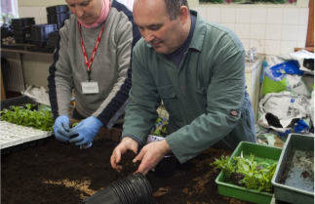
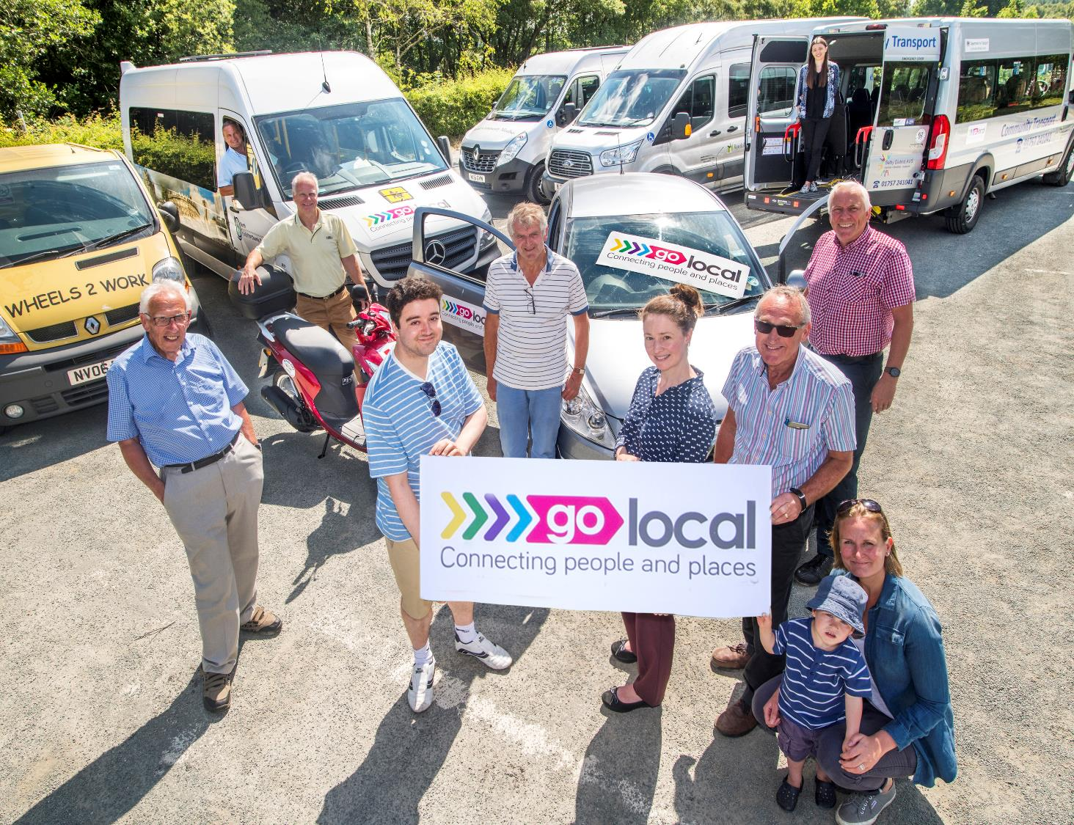
People|Places|Power
Building Stronger Communities in North Yorkshire
How to apply

This form should be completed for all applications for Place Based Community Anchor Organisation Grants.

Applications should be submitted by 12 noon on 16th January 2026. Please return an electronic copy of your completed application form and any associated documentation or attachments by email to:

stronger.communities@northyorks.gov.uk

The application form must be returned as a word document.
Please do not convert it to a PDF.

Evaluation of Applications

Applicants will be notified regarding the outcome of their application by the end of February 2026.

Further information
If you would like further information about this opportunity or if you would like to discuss the submission of an application, please contact the Communities Locality Lead for Scarborough, Malton & Vale:

Karen Atkinson
Tel: 01609 534061
Email: karen.atkinson@northyorks.gov.uk

SECTION 1: TELL US ABOUT YOUR ORGANISATION

Q1 Name of your organisation:
Q2 Name of main contact:
Q3 Address of organisation or main contact:
Telephone:
Email:
Q4 What is the status of your organisation?
☐ Unincorporated community group
☐ Faith organisation
☐ A Registered Charity / CIO
(please state number)
☐ Other Not for Profit / Social Enterprise
(please state type e.g. CIC, Company Limited by Guarantee etc.)
☐ Other (please state)
Q5 How long has your organisation been established?
Q6 For which place do you wish to be the Community Anchor Organisation?

Q7 Please tell us where your organisation is based and describe how you currently serve or have the potential to serve the area of Malton & Norton. What other places do you think your residents might visit to access services or build connections?
(Maximum 250 words)
Q8 Tell us about the Malton & Norton area.
What is great about it? Also, what challenges does it present for residents?
(Maximum 200 words)
Q9 Which characteristics of a Community Anchor does your organisation demonstrate now? Please tell us about these in strength order with those characteristics you believe you show most strongly first using brief examples to explain your answer. It is important to be as accurate as you can in your self-assessment, remember the purpose of this investment is to support the development of Community Anchors so we don’t expect organisations to demonstrate all the characteristics or to be as strong in all areas.
See pages 5-9 of Invitation to Bid
(Maximum 800 words)
Q10 This funding is to build capacity and support the on-going development of Anchors. Tell us about any of the characteristics of a Community Anchor Organisation which you feel your organisation does not have or needs to develop more fully. What might help you to make progress in any areas you have identified?
(Maximum 500 words)
Q11a Tell us about your relationships with other local organisations in your area which address local needs. What evidence do you have that they will recognise you as well suited to the Community Anchor role?
(Maximum 250 words)
Q11b Thinking about your answer to question 11a. It would help us if we could contact a couple of local organisations to have a short conversation with them about how they work with you. Please provide contact information for each organisation below including: name of the organisation, a contact name, phone number and email address.
Q12 Please describe the services and activities that you are already delivering on a day-to-day basis.
(Maximum 500 words)
See page 10 of Invitation to Bid for the types of services and activities that an anchor may deliver
SUPPORTING INFORMATION CHECKLIST
Please complete the checklist below and ensure that you have enclosed the relevant paperwork to support your application. Please note that this list is not exhaustive and you may be asked for additional supporting information which is not detailed below.

Supporting Information |  |  | Tick
Constitution / Memorandum and Articles of Association of Organisation (VCSE organisations) |  |  | ☐
A signed copy of latest audited accounts |  |  | ☐
Copy of Safeguarding Policy |  |  | ☐
Copy of Equalities and Diversity Policy |  |  | ☐
Please detail the insurance cover (i.e. public liability, employer liability, cyber insurance and / or buildings and contents) that your organisation has in place that is relevant to this application.
Please confirm that the appropriate Disclosure and Barring Service (DBS) checks been carried out on those staff working with and / or supporting proposed beneficiaries.
Yes ☐ No ☐
Please confirm that your processes are GDPR compliant.
Yes ☐ No ☐
If there is a reason why you have been unable to supply any of the information outlined in Section 3, or if you believe we already have copies of this information please let us know in the box below.
Declaration:
I the undersigned confirm that I have the authority to submit this funding application on behalf of the organisation named in Q1
Signature of Applicant:
Date:
Data Protection:
All the information you enter on this form will be stored and held in accordance with relevant data protection legislation and used by North Yorkshire Council and its agents for the purpose of analysing, recording and publicising grants.
☐ | Please check the box to indicate you have read this statement and agree to your data being used for these purposes.
If you do not agree to this, please write stating this fact to the address below.
Stronger.communities@northyorks.gov.uk

